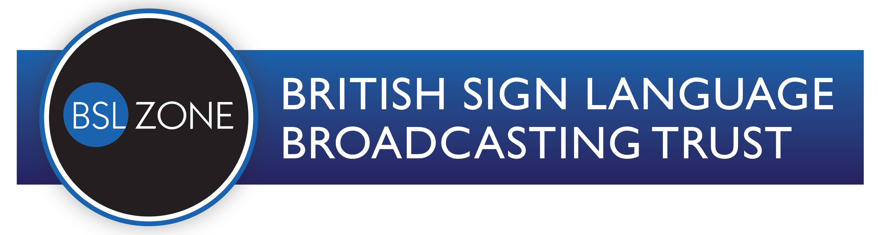
Reaching every BSL user with more of the BSL content that they love to watch

Deaf Producers, Directors and Producer/Directors are invited to submit ideas for the
Spring 2020 factual development round

Closing date: Wednesday 3rd June 2020

Introduction:
- We want ideas for single or series of 28-minute programmes for television which reflect the richness and diversity of BSL and Deaf life and culture
- You have six weeks to work on ideas and complete the information below
- You can submit up to three ideas
- The ideas will be assessed by BSLBT’s Commissioning Advisory Panel and the BSLBT Board.
- If your idea is selected by BSLBT, it will go into a funded development period on BSLBT’s standard terms

Eligibility to apply:
To submit a proposal, you must be over the age of 18, live in the UK and:
- be Deaf and have made a 28-minute television programme; and
- be the director or producer of this proposal; and
- be attached to a production company that has made 28-minute programmes for broadcast TV

What we are looking for:
- Your programme/series ideas could focus on one person, or a group of people, AND/OR
- could be built around a theme, or an event
- could be, for example, a documentary, history or arts, a chat or quiz show, a lifestyle or entertainment programme
- You could submit an idea for a pilot programme for a potential series

Key points about BSL Zone factual programmes:
- They must have contributors who use BSL.
- They must be fully accessible to a Deaf BSL user.
- Rights must be cleared in all media, in perpetuity, worldwide unless agreed otherwise.
- A single programme duration is between 27-28 minutes, with no breaks.
- The guide budget for a 28-minute programme is between £20k to £60k.
- They must be appropriate for a family audience at 8am on the BSL Zone Film4 slot.

You are welcome to discuss ideas before submitting your proposal. This can be done by video calls which can be arranged with Maggie Swinfen, the BSLBT Head of Commissioning, by emailing: Maggie.swinfen@bslbt.co.uk

Statement
By submitting a proposal, you:
- confirm that you are the sole and exclusive owner of the proposal and you are formally submitting it to this BSLBT Spring 2020 tender round.

- understand that BSLBT may already be exploring similar programme proposals and/or ideas which are similar to your proposal and that, in some cases, similar or identical ideas may be generated independently.
- agree that BSLBT may discuss your proposals with staff, Board members and the BSLBT Commissioning Advisory Panel.
- agree that your proposal will be archived and saved on our internal IT systems.
- confirm that you have read and understand the Privacy Notice for Programme Proposal Submissions attached.
Timetable:
- Midday, Wednesday 3rd June:
Deadline for initial application

Wednesday 24th June:
Funded development commences on selected programme proposals

- Wednesday 2nd September:
Deadline for delivery of development work

- Tuesday September 22nd:
Commissioning decisions made at September Board meeting (and successful proposals could be produced in 2021 or retained by BSLBT for possible commission for up to 3 years from the decision date)

BSLBT reserves the right to vary the above timetable and will notify successful applicants of any change.

23 April 2020
PROGRAMME PROPOSAL SUBMISSION FORM

WORKING TITLE OF THE PROGRAMME

A two line summary

A paragraph summary

An indicative running order

About you

1. Who is the Deaf producer, director, or producer/director behind this proposal and what is their broadcast TV experience?

2. Who will the Executive Producer be? What is their relevant experience?

3. Who will the production company(ies) be and what is their broadcast TV experience?
(Company name, contact details, website)

About the programme

1. Explain why you think BSLBT should make this programme?

2. What journey will it take the audience on, what is the storyline or idea, what does your programme explore?

3.How will you engage the audience in this programme?

4. Describe the visual style of the programme?

5. What and who would you spend development money on?

BSL Zone programmes must be fully accessible in BSL:

4. How will you make sure that you film sign language so that it is visible and clear enough for a BSL audience to follow?

5. How will our Deaf audience understand any contributors who use spoken English?

